# Module 1 Comprehensive Guide

## Introduction to Deep Learning and Neural Networks

## 📌 Introduction to Deep Learning

Deep learning is a powerful and fast-evolving field within data science that enables machines to perform tasks previously thought to require human intelligence. Its ability to learn directly from raw data and discover intricate patterns has led to major breakthroughs in various domains.

Key strengths of deep learning models:

* Learn hierarchical representations automatically from data.
* Generalize effectively to unseen, real-world tasks.
* Handle unstructured inputs such as images, text, and audio.

### 🔹 Real-World Applications of Deep

Several current applications demonstrate the practical capabilities and versatility of deep learning models.

**🖼 Color Restoration**

* Grayscale images are transformed into colored versions using **convolutional neural networks (CNNs)**.
* The system learns color patterns from large datasets and applies them to monochrome input.
* Useful for enhancing historical media or generating stylized imagery.

**🗣 Speech Enactment**

* Deep learning models can synthesize audio with video by aligning lip movements with speech.
* A system built using **recurrent neural networks (RNNs)** enables realistic speech-video generation.
* This technology has been applied to create natural-looking speech reenactments from mismatched audio and video inputs.

**✍ Handwriting Generation**

* **RNNs** are also used to convert typed messages into lifelike cursive handwriting.
* The system can replicate different handwriting styles, either randomly or through user selection.
* Demonstrates the generative capabilities of sequence models.

### 🔹 Additional Notable Use Cases

Beyond the highlighted examples, deep learning has enabled solutions in a wide range of tasks:

* **Automatic Machine Translation**: Translating text in real time, including text embedded in images.
* **Sound Generation**: Adding synchronized soundtracks to silent video based on scene context.
* **Image Classification and Object Detection**: Identifying objects and classifying them into categories.
* **Self-Driving Vehicles**: Processing sensor and visual data to navigate and make decisions autonomously.
* **Conversational AI**: Powering dynamic, context-aware chatbots.
* **Text-to-Image Generation**: Creating images based on natural language prompts using generative models.

### 🔹 Takeaways

✅ Deep learning has rapidly advanced into a critical area of modern AI, enabling tasks that go beyond the reach of traditional machine learning.

✅ These models are especially effective in domains involving vision, audio, and language—where they outperform hand-engineered approaches.

✅ The core architecture behind these applications is the **neural network**, which will be explored in detail throughout this module.

## 📌 Neurons and Neural Networks

### 🔹 Biological Neurons: Structure and Function

Deep learning algorithms are fundamentally inspired by the structure and functioning of neurons in the human brain. Understanding how biological neurons operate helps provide context for the architecture of artificial neural networks.

**🧠 Components of a Neuron:**

* **Soma**: The main body of the neuron that contains the nucleus. It processes the incoming signals.
* **Dendrites**: Branch-like structures that receive electrical impulses (signals) from other neurons.
* **Axon**: A long fiber that transmits the processed signal away from the soma.
* **Synapses (or terminal buttons)**: Located at the end of the axon, they pass the output signal to the dendrites of neighboring neurons.

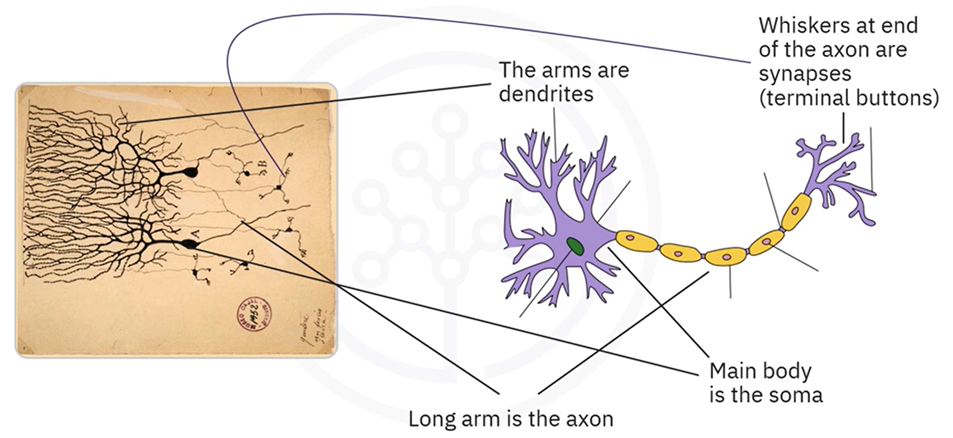

**🔄 Signal Propagation in the Brain:**

1. Dendrites receive electrical signals from the synapses of connected neurons.
2. Signals are transmitted to the **soma**, where they are aggregated and processed.
3. The result is passed through the **axon** to the **synapses**.
4. Synapses transmit the signal to thousands of other neurons, forming a dense, interconnected network.

This mechanism allows the brain to process sensory information, react to stimuli, and learn from experience through repeated activation of useful connections.

### 🔹 Learning in Biological Neural Networks

Learning occurs by **reinforcing specific neural pathways**.

* The more a particular connection is used to produce a successful output, the stronger it becomes.
* This reinforcement makes the pathway more likely to activate again when similar input is received.

This concept of **adaptive strengthening of connections** forms the basis of learning in both biological and artificial neural systems.

### 🔹 Artificial Neurons: Modeled Behavior

Artificial neurons are computational representations designed to mimic the functional structure of biological neurons.

* **Inputs** represent signals received from other neurons (analogous to dendrites).
* **Aggregation and activation** occur at the core of the neuron (analogous to the soma).
* **Output** is passed to subsequent neurons through weighted connections (analogous to the axon and synapses).

Like in the brain, artificial neurons are connected in **networks**, and the strength of each connection (represented by weights) can be adjusted during training to reinforce useful patterns.

| **Biological Component** | **Artificial Equivalent** |
| --- | --- |
| Dendrites | Input signals / features |
| Soma (with nucleus) | Weighted sum + activation |
| Axon | Output of the neuron |
| Synapse | Connection to other neurons |

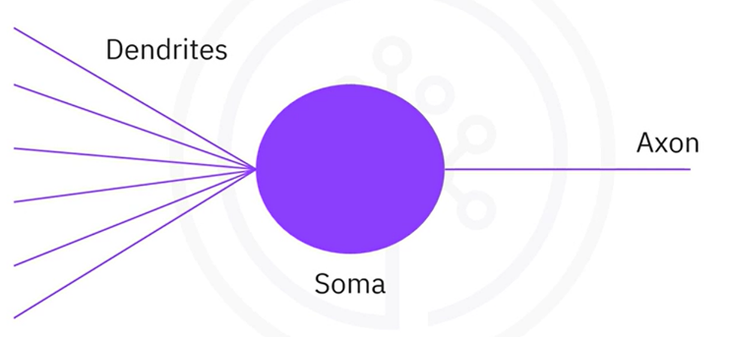

Both systems:

* Receive input signals
* Process and combine those inputs
* Generate outputs that influence subsequent components in the network

✅ Deep learning models are directly inspired by how neurons process and transmit information.

✅ Artificial neurons retain the key behavioral aspects of biological neurons, enabling them to learn patterns through weighted connections.

✅ The structure of neural networks is modeled on the interconnected nature of neurons in the brain, where outputs from one neuron become inputs for many others.

## 📌 Artificial Neural Networks

### 🔹 Foundations of Neural Networks

Artificial neural networks (ANNs) are inspired by the structure and function of biological neurons. The fundamental unit of an ANN is the **artificial neuron**, also referred to as a **perceptron**. Neural networks consist of many such neurons organized into layers that process and propagate information.

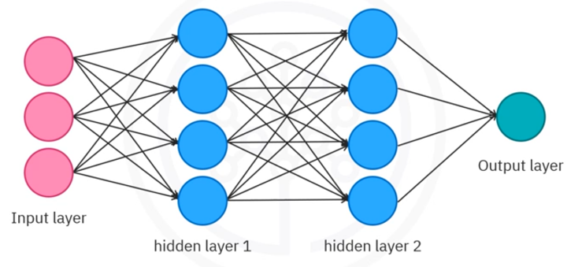The architecture typically includes:

* **Input Layer**: Receives external data and feeds it into the network.
* **Hidden Layers**: Intermediate layers that apply transformations to the data.
* **Output Layer**: Produces the final result or prediction of the network.

When working with neural networks, there are three essential concepts to understand:

1. **Forward Propagation** – how data flows through the network
2. **Backpropagation** – how the network learns from errors
3. **Activation Functions** – how non-linearity is introduced

This section focuses on **forward propagation**, which is the process by which input data moves through the layers of a neural network—from input to output—transforming at each layer. The flow of information is regulated by the **weights** assigned to each connection, which can be thought of as controlling the strength of each input.

The neurons receive input values (e.g., x1x_1x1​, x2x_2x2​), adjust them using their respective weights (e.g., w1w_1w1​, w2w_2w2​), and then process them through a mathematical function to produce an output. This structure mimics biological connections and enables a network of neurons to compute increasingly abstract representations.

### 🔹 The Perceptron: Mathematical Formulation

Let:

* **​** be the input values
* **​** ​ be the weights associated with those inputs
* **b** be the bias term

An artificial neuron processes inputs using a simple mathematical operation.

The neuron computes a **linear combination** of inputs and weights, then adds the bias:

To introduce non-linearity and enable the network to model complex relationships, the neuron applies an **activation function** to :

Here:

* : weighted sum + bias
* : output of the neuron
* : activation function (e.g., sigmoid, ReLU)

This formulation allows the network to learn from data and adapt the weights and biases to minimize prediction error.

### 🔹 Activation Functions and Their Role

A neural network without activation functions is essentially equivalent to a linear model. To overcome this limitation, activation functions introduce non-linearity, allowing the network to learn and approximate complex patterns and decision boundaries.

**🔸 Example: Sigmoid Activation**

The **sigmoid function** is a common choice in binary classification:

It maps to value between 0 and 1:

* If is a large positive number,
* If is a large negative number,

Other activation functions (not covered yet but implied) include ReLU, tanh, and softmax.

ℹ️**Note:** **Without activation functions, a neural network collapses to a linear regression model and loses the capacity to solve non-linear problems**.

### 🔹 Forward Propagation in Detail

**Forward propagation** is the process by which data moves through the neural network from the input layer to the output layer. Each neuron:

1. Receives inputs.
2. Computes a weighted sum.
3. Adds a bias.
4. Applies an activation function.
5. Passes the result to the next layer.

This happens layer by layer, allowing the network to transform the input data progressively into a meaningful output.

#### ⚙️Example: Single Neuron Forward Propagation

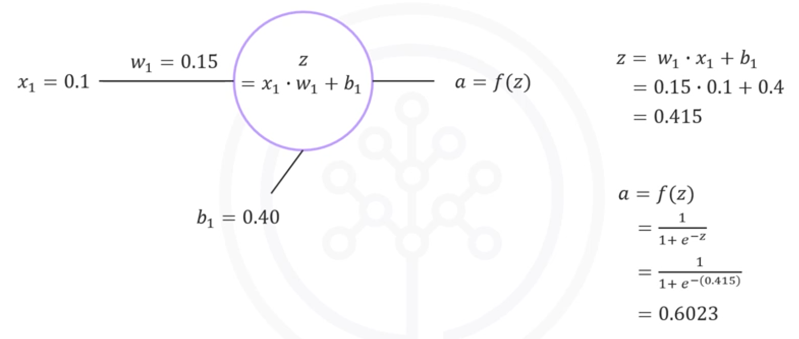

**This value (0.6023) is the output of the neuron.**

#### ⚙️Example: Two-Neuron Chain

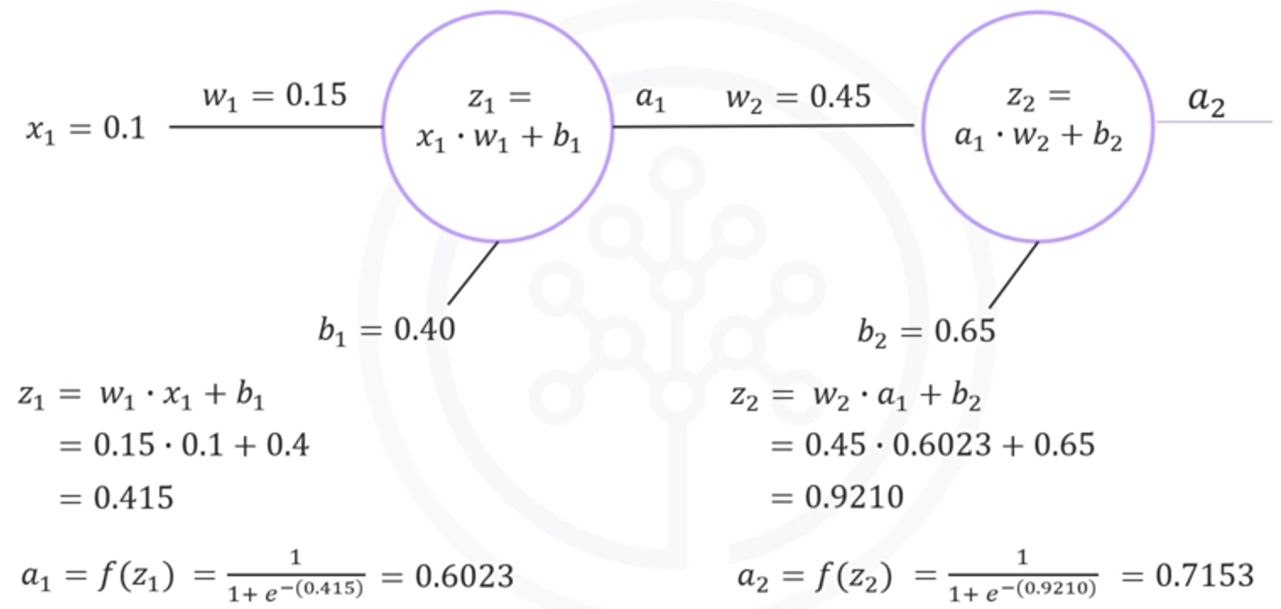

So, for an input of , the network outputs a final prediction of approximately **0.7153**.

**🧠 Generalization:**

No matter how large or complex the network becomes, this step-by-step pattern—linear combination + activation—remains the same.

Neural networks rely on **layered computation**, and each layer transforms the input into a higher-level representation. This hierarchy enables the network to learn abstract concepts from raw data.

### 🔹 Takeaways

✅ Artificial neurons (perceptrons) compute a **weighted sum + bias**, followed by an **activation function**.

✅ Neural networks are made up of **layered perceptrons**, and each layer builds on the representation of the previous one.

✅ **Forward propagation** is the core mechanism that drives prediction in a neural network.

✅ Activation functions are essential to break linearity and enable deep learning models to capture complex relationships.

✅ With known weights and biases, it's possible to compute the output of any neural network given an input — regardless of its depth or width.

✅ The concepts of **backpropagation** and deeper insights into **activation functions** will further extend this foundation and are addressed in upcoming sections.